

STUDENT CASE STUDY EXECUTION REPORT

CASE STUDY EXECUTION REPORT
Department | FED
Subject | DSA-2
Academic Year | I-III Semester(2025-26)
Faculty Name | Ms Swathi
Student Name | CH.VIVEK
Roll Number | 2520030532
Branch | CSE
Course Outcome | CO-5

Case Study Topic: CivicEye – Smart City Incident Monitoring & Response System

Work Done Summary:

In this case study, we implemented Hashing Techniques for the CivicEye Smart City Incident Monitoring & Response System.

Hashing was used to store and retrieve incident records efficiently using IncidentID as the key.

The system enables quick access to incident details without traversing large datasets.

Collision handling techniques were applied to maintain efficient performance during record insertion and retrieval.

Implementation Details:

Implemented Hash Table to store incident records using IncidentID.

Used a hash function to map IncidentIDs to storage locations.

Applied collision handling using Linear Probing.

Enabled fast searching and retrieval of incident information.

Compared hashing performance with sequential searching methods.

Concluded hashing significantly improves record access speed in smart city systems.

Result: Screenshots / Output

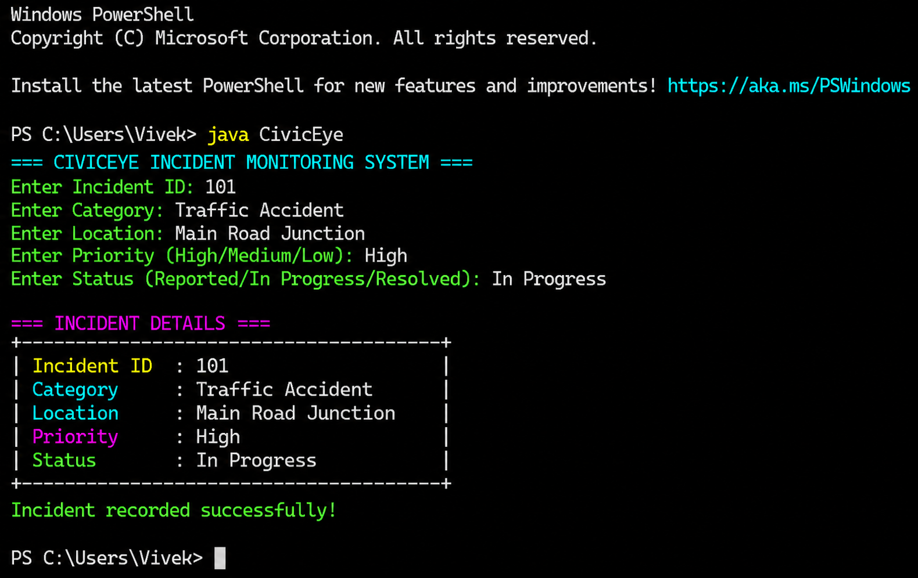

- The implemented system efficiently stored and retrieved incident records using hashing techniques.
- The hash table reduced searching time and provided direct access to incident information.
- Collision handling ensured reliable performance even when multiple IncidentIDs mapped to the same location

GitHub Link: vivekcherukumalli7-beep/DSA2_CIVICEYE_PROJECT

